Test Case – Plan 3 for

**DB2 Inventory Management Project**

**Prepared by:**

Jessica Fritschle

Ellis Hunter

Abimbola Otugalu

Jeremy Worthy

Michael Goetschius

**CMSC 495  
Prof. Metallo**

Test Case #3



Test Case #6



Test Case #8



Test Case#10



Test Case #11

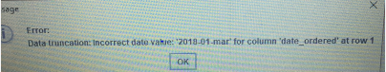

Test Case#12



Test Case# 13



Test Case #14

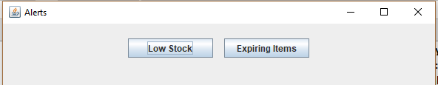

Test Case#15

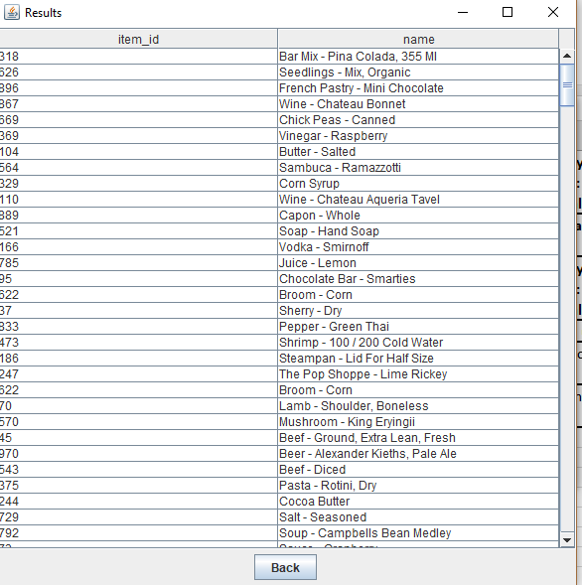

Test Case#16

